FoodBridge Navigator

1. Purpose and scope
FoodBridge Navigator improves access to existing food-support services by transforming fragmented public and community data into personalised, explainable, and location-aware recommendations.

2. Target users and stakeholders

Group | Needs | MVP interaction
Food-support seeker (primary) | Find appropriate support quickly without an account; understand eligibility, freshness, and travel implications. | Search, compare, inspect details, plan a route, contact a provider, and report an error.
FoodBridge administrator (operational) | Protect data quality and maintain traceability. | Look at reports and update to correct information
Data provider | Supply authorised organisation, service, or route data. | Provides data through an import or external API; no separate MVP UI.

3. Elicitation and refinement
The course team uses a role-based workshop: some members act as seekers, social-service workers, organisation staff, and administrators; the remaining members act as analysts. The team elicits requirements through:
- scenario walkthroughs (for example, finding a halal cooked meal within 5 km);
- semi-structured interviews about each actor's input, decision, and required output;
- review of data.gov.sg, FoodConnect, The Food Bank Singapore directory, and OneMap capabilities and constraints;
- walkthroughs of the UI mockups in ui-mockups.md; and
- checks for necessity, feasibility, clarity, consistency, atomicity, and verifiability.
The principal findings are that a search must be low effort, opening status must remain separate from food availability, uncertain data must be labelled cautiously, and public users must be able to search and report errors without an account.

4. Functional requirements

4.1 Public Search and Recommendation
Requirement ID | Requirement | Description / Expected Behaviour
4.1.1.1 | Submit a search origin | The system shall allow a public user to submit one search origin.
4.1.1.2 | Use a postal code | The system shall accept a six-digit Singapore postal code as a search origin.
4.1.1.3 | Use an address | The system shall accept a Singapore address as a search origin.
4.1.1.4 | Use the device location | The system shall allow a public user to use the device's current location as the search origin.
4.1.1.5 | Validate the search origin | The system shall validate each submitted search origin before running a search.
4.1.2.1 | Specify dietary needs | The system shall allow a public user to select or specify zero or more dietary needs. The selected dietary needs are recorded as search criteria.
4.1.2.2 | Specify a maximum distance | The system shall allow a public user to specify one maximum distance for the search. The specified maximum distance is recorded as a search criterion.
4.1.2.3 | Specify a preferred service time | The system shall allow a public user to specify one preferred service date and time. The specified service date and time are recorded as search criteria.
4.1.3.1 | Match approved services | The system shall return approved services that satisfy every selected mandatory criterion.
4.1.3.2 | Calculate distance | The system shall calculate the distance from the search origin to each returned service.
4.1.3.3 | Estimate travel time | The system shall request an estimated travel time for each returned service when routing is available.
4.1.3.4 | Rank matching services | The system shall rank returned services using match quality, distance, operating status, and information freshness.
4.1.4.1 | Display the organisation name | The system shall display the organisation name for each search result.
4.1.4.2 | Display the support type | The system shall display the support type for each search result.
4.1.4.3 | Display the distance | The system shall display the distance for each search result.
4.1.4.4 | Display the operating status | The system shall display the operating status for each search result.
4.1.4.5 | Display the public availability label | The system shall display the public availability label for each search result.
4.1.4.6 | Explain each recommendation | The system shall display a recommendation explanation for each search result.
4.1.4.7 | Display service details | The system shall display the approved details of a service selected by a public user.
4.1.4.8 | Display a travel warning | The system shall display a contact-before-travelling warning on every service-detail view.
4.1.4.9 | Display map markers | The system shall display map markers corresponding to the currently returned services.
4.1.5.1 | Display a no-results message | The system shall display a no-results message when no approved service satisfies every mandatory criterion.
4.1.5.2 | Offer an edit-filters action | The system shall offer an edit-filter action with each no-results message.
4.1.5.3 | Preserve applied criteria | The system shall preserve the applied criteria when a public user edits a search.

4.2 Route Planning and Contact
Requirement ID | Requirement | Description / Expected Behaviour
4.2.1.1 | Request a route | The system shall allow a public user to request a route to a selected service.
4.2.1.2 | Display the route map | The system shall display a successful OneMap route on a map.
4.2.1.3 | Display the route distance | The system shall display the distance returned for a successful route.
4.2.1.4 | Display the route duration | The system shall display the duration returned for a successful route.
4.2.2.1 | Display a routing-unavailable message | The system shall display a routing-unavailable message when OneMap cannot return a route.
4.2.2.2 | Retain service details after failure | The system shall keep approved service details visible after a route request fails.
4.2.3.1 | Present a telephone action | The system shall present an approved telephone action when an approved telephone number exists.
4.2.3.2 | Present a website action | The system shall present an approved website action when an approved website exists.
4.2.3.3 | Handle missing contact information | The system shall display Contact information not confirmed when no approved contact method exists.

4.3 Availability, Freshness, and Imported Data
Requirement ID | Requirement | Description / Expected Behaviour
4.3.1.1 | Store an availability status | The system shall assign each availability observation exactly one stored status from AVAILABLE, LIMITED, UNAVAILABLE, UNKNOWN, or EXPIRED.
4.3.1.2 | Store the observation source | The system shall store the source of each availability observation.
4.3.1.3 | Store the observation time | The system shall store the observation time of each availability observation.
4.3.1.4 | Store the validity end time | The system shall store the validity end time of each availability observation.
4.3.1.5 | Store a confidence level | The system shall store one confidence level for each food-bank availability observation.
4.3.2.1 | Expire outdated observations | The system shall change an availability observation to EXPIRED when its validity end time passes.
4.3.2.2 | Present expired availability as unknown | The system shall present an EXPIRED observation to a public user as Availability unknown.
4.3.2.3 | Display the availability source | The system shall display the source supporting a public availability label.
4.3.2.4 | Display the observation time | The system shall display the observation time supporting a public availability label.
4.3.2.5 | Display the validity end time | The system shall display the validity end time supporting a public availability label.
4.3.2.6 | Display the confidence level | The system shall display the confidence level supporting a public availability label.
4.3.2.7 | Display cached-data freshness | The system shall display the time of the last successful local update when cached data is used.
4.3.3.1 | Store organisation-record sources | The system shall store the source of every imported organisation record.
4.3.3.2 | Store service-record sources | The system shall store the source of every imported service record.
4.3.3.3 | Store import times | The system shall store the import time of every imported record.
4.3.4.1 | Quarantine invalid records | The system shall quarantine an imported record that fails schema validation.
4.3.4.2 | Store validation reasons | The system shall store a validation reason for each quarantined record.
4.3.4.3 | Flag suspected duplicates | The system shall flag a suspected duplicate organisation for administrator review.

4.4 Public Corrections, Authentication, and Organisation Changes
Requirement ID | Requirement | Description / Expected Behaviour
4.4.1.1 | Submit a correction | The system shall allow a public user to submit one correction for a listed service.
4.4.1.2 | Require a correction category | The system shall require one correction category for each submitted correction.
4.4.1.3 | Validate the correction description | The system shall require a description of 1 to 1000 characters for each submitted correction.
4.4.1.4 | Return a report reference | The system shall return a unique reference identifier for each accepted correction report.

4.5 Administration and Moderation
Requirement ID | Requirement | Description / Expected Behaviour
4.5.1.1 | Display pending corrections | The system shall display pending correction reports to an administrator.
4.5.1.2 | Display pending organisation changes | The system shall display pending organisation change requests to an administrator.
4.5.1.3 | Compare current and proposed information | The system shall display current and proposed information for a selected moderation item.
4.5.2.1 | Approve a moderation item | The system shall allow an administrator to approve one pending moderation item.
4.5.2.2 | Publish approved values | The system shall publish a proposed value only after its moderation item is approved.
4.5.2.3 | Require a rejection reason | The system shall require a rejection reason before rejecting a pending moderation item.
4.5.2.4 | Reject a moderation item | The system shall allow an administrator to reject one pending moderation item.
4.5.2.5 | Prevent duplicate decisions | The system shall prevent a second decision on a decided moderation item.
4.5.3.1 | Record the decision actor | The system shall record the actor of each moderation decision.
4.5.3.2 | Record the decision action | The system shall record the action of each moderation decision.
4.5.3.3 | Record the target identifier | The system shall record the target identifier of each moderation decision.
4.5.3.4 | Record the decision timestamp | The system shall record the timestamp of each moderation decision.
4.5.3.5 | Display audit entries | The system shall display moderation audit entries to an administrator.
4.5.4.1 | Display suspected duplicates | The system shall display suspected duplicate organisations to an administrator.
4.5.4.2 | Display data-source health | The system shall display data-source health and last-successful-import time to an administrator.

5. Non-functional requirements

5.1 Performance and Responsiveness
Requirement ID | Requirement | Description / Expected Behaviour
5.1.1 | Cached-search response time | The system shall return a cached search response within 0.5 seconds for at least 95% of requests.
5.1.2 | Route-response time | The system shall display a route or routing-unavailable message within 5 seconds for at least 95% of requests while OneMap operates normally.

5.2 Availability and Resilience
Requirement ID | Requirement | Description / Expected Behaviour
5.2.1 | Monthly availability | The deployed application shall achieve 99% monthly availability, excluding announced maintenance.
5.2.2 | External-source failure handling | The system shall provide search from the most recent successful local dataset while an external data source is unavailable.

5.3 Privacy
Requirement ID | Requirement | Description / Expected Behaviour
5.3.1 | Device-location retention | The system shall not retain a public user's device location after the search session ends.

5.4 Usability
Requirement ID | Requirement | Description / Expected Behaviour
5.4.1 | First-time-user task completion | At least 80% of five or more first-time representative users shall complete a location-and-filter search within 2 minutes without assistance.

5.5 Compatibility
Requirement ID | Requirement | Description / Expected Behaviour
5.5.1 | Android support | The app shall support devices running Android 12 (released in 2021) and later versions.

5.6 Data Durability
Requirement ID | Requirement | Description / Expected Behaviour
5.6.1 | Daily database backup | The production database shall complete at least one backup in every 24-hour period.

6. Assumptions and constraints
- Singapore is the only geographic scope for the MVP.
- English is the MVP interface language.
- FoodConnect and Food Bank data is imported only with permission or an authorised export.
- A manually verified seed dataset is used when detailed partner data is unavailable.
- OneMap is the intended geocoding and routing provider.
- Availability is evidence with a validity period; it is never a reservation or guarantee.

- Fill up includes relationships in the table
- SPecial requirements: Fr1.2 (reference)
- Need to address functional requirements
Use Case ID: | 01
Use Case Name: | Find Food Support
Created By: | Jamien | Last Updated By:
Date Created: | 7/9/2026 | Date Last Updated:

Actor: | Public User
Description: | Allows the Public User to find approved food support services that match the user’s location and needs
Preconditions: | The search form is available  - Approved food support service data is available and cached
Postconditions: | Matching Approved food services are displayed  - Results include match explanations, freshness information and map markers
Priority: | High
Frequency of Use: | On demand
Flow of Events: | The system displays the search form.  - The actor enters an origin and optional criteria.  - The actor submits the search.  - The system validates the origin and criteria.  - The system filters and ranks approved services.  - The system displays results, match explanations, freshness information, and map markers. (extends to Use Case - 02 (UC-02)
Alternative Flows: | Invalid origin: show an error and preserve input.  No matches: show recovery actions.  External failure: use cached data and show its update time.  Routing failure: show Travel time unavailable.  - The actor identifies incorrect service information and chooses to report it. (extends to Use Case - 04 (UC-04))
Exceptions: | Unexpected system failure: Display an error and allow the user to retry.
Includes: | -
Special Requirements: | Only approved services are displayed  - Results must include freshness information and match explanations  - User input must be preserved when validation fails
Assumptions: | The actor does not need to sign in  - The actor can provide an origin  - Current or cached approved service data is available
Notes and Issues: | -

Use Case ID: | 02
Use Case Name: | View Available Food Support
Created By: |  | Last Updated By:
Date Created: | 7/9/2026 | Date Last Updated:

Actor: | Public User
Description: | Decide whether a selected food support service may be suitable.
Preconditions: | - The selected service’s approved details, operating status, availability label, and supporting evidence are displayed.  - The actor can use any available approved contact action or request a route.
Postconditions: | - The selected service’s approved details, operating status, availability label, and supporting evidence are displayed.  - The actor can use any available approved contact action or request a route.
Priority: | High
Frequency of Use: | High
Flow of Events: | - The actor selects a service.  - The system retrieves its approved organisation and service details.  - The system displays the support type, eligibility, location, operating hours, and other approved details.  - The system displays operating status separately from food availability.  - The system presents approved telephone and website actions where available, plus a route action when directions can be requested.
Alternative Flows: | Unknown information is shown as Not confirmed.  If approved contact data is unavailable, no empty contact button is displayed.  Actor requests directions: UC-03 Plan Route begins.  Actor identifies incorrect information: UC-04 Report Incorrect Information begins.
Exceptions: | Unexpected system failure: display an error and allow the user to retry.
Includes: | -
Special Requirements: | -
Assumptions: | The selected service has approved information available or cached.
Notes and Issues: | -

Use Case ID: | 03
Use Case Name: | Plan Route
Created By: |  | Last Updated By:
Date Created: | 7/9/2026 | Date Last Updated:

Actor: | Public User
Description: | Allows a public user to request and view a route from a chosen origin to a selected food-support service
Preconditions: | 1. The actor has selected a food-support service.  2. The selected service has a valid destination location.  3. A valid starting location is available from the search origin, device location, or actor input.  4. The route action is available on the service-detail page.
Postconditions: | Success: A route map, route distance, and estimated duration are displayed.  Failure: The selected service’s details remain visible and a routing-unavailable message is displayed.  No service or user information is modified.
Priority: | High
Frequency of Use: | Often - Whenever the user needs the direction to a selected service.
Flow of Events: | - The actor requests a route and selects a travel mode.  - The system sends the origin and destination to OneMap.  - OneMap returns a route.  - The system displays the route, distance, duration, and attribution.
Alternative Flows: | A1 — Starting location is unavailable: The system asks the actor to enter an address or six-digit Singapore postal code.  A2 — Device-location permission is denied: The system allows the actor to manually enter an address or postal code.  A3 — OneMap cannot return a route: The system displays Route unavailable, keeps the service details visible, and allows the actor to retry or use an available contact action.
Exceptions: | E1 — OneMap is temporarily unavailable: The system displays a routing-unavailable message and allows the actor to retry later.  E2 — Network or unexpected system failure: The system displays an error message without removing the selected service’s details.  E3 — The destination location is invalid or missing: The system does not submit the route request and informs the actor that directions are currently unavailable.
Includes: | -
Special Requirements: | -
Assumptions: | 1. The actor has network access when requesting the route.  2. The actor entered a valid origin/ destination
Notes and Issues: | -

Use Case ID: | 04
Use Case Name: | Report incorrect Information
Created By: |  | Last Updated By:
Date Created: | 7/9/2026 | Date Last Updated:

Actor: | Public User
Description: | Allows a public user to submit a correction report when the user believes that information displayed for a food-support service is inaccurate, incomplete, or outdated.
Preconditions: | 1. The actor is viewing an approved food-support service.  2. The correction-reporting action is available.  3. The selected service has a valid identifier that can be associated with the report.
Postconditions: | Success: The correction report is stored with a Pending status and linked to the selected service. A unique reference identifier is displayed to the actor.  Failure: No report is stored, and the actor’s entered information is preserved where possible. Published service information is not changed by submitting a report.
Priority: | Medium
Frequency of Use: | Occasional — whenever a public user notices suspected incorrect, incomplete, or outdated service information.
Flow of Events: | 1. The actor selects the report-incorrect-information action for a service.  2. The system displays the correction form and identifies the selected service.  3. The actor selects one correction category.  4. The actor enters a description of the suspected error.  5. The actor optionally provides supporting evidence, if this feature is available.  6. The actor submits the correction report.  7. The system validates the selected category and description.  8. The system assigns a unique reference identifier to the report.  9. The system stores the report with a Pending status and links it to the selected service.  10. The system displays the reference identifier and informs the actor that the report is awaiting administrator review.
Alternative Flows: | A1 — No category is selected: The system displays an error beside the category control and in the validation summary. The actor’s other input is preserved.  A2 — Description is missing or invalid: The system explains that the description must contain between 1 and 1000 characters. The actor’s input is preserved for correction.
Exceptions:
Includes: | -
Special Requirements: | -
Assumptions: | 1. The actor has network access when requesting the route.  2. The actor entered a valid origin/ destination
Notes and Issues: | -

Use Case ID: | 05
Use Case Name: | View Saved Services
Created By: |  | Last Updated By:
Date Created: | 7/9/2026 | Date Last Updated:

Actor: | Public User
Description: | Allows the user to view food-support services saved during previous sessions.
Preconditions: | The user has previously saved at least one food-support service.
Postconditions: | The saved services are displayed. No saved information is changed.
Priority: | Medium
Frequency of Use: | Occasional
Flow of Events: | 1. The actor opens the saved-results tab.  2. The system retrieves the saved services.  3. The system displays the saved services.  4. The actor selects a service.  5. The system displays its details through UC-02.
Alternative Flows: | If no services have been saved, the system displays No saved results and provides an action to find food support.
Exceptions: | If the saved results cannot be loaded, the system displays an error and allows the actor to retry
Includes: | -
Special Requirements: | Saved services must use their latest approved information.
Assumptions: | Saved results are stored on the same device
Notes and Issues: | -

Use Case ID: | 06
Use Case Name: | Update Food Support Information
Created By: |  | Last Updated By:
Date Created: | 7/9/2026 | Date Last Updated:

Actor: | FoodBridge Administrator
Description: | Allows an administrator to update approved organisation and food-support service information
Preconditions: | The administrator is signed in and authorised. The organisation or service record exists.
Postconditions: | The approved information is updated and the change is recorded in the audit log.
Priority: | High
Frequency of Use: | Medium
Flow of Events: | 1. The system displays organisations and services available for update.  2. The administrator searches for and selects a record.  3. The system displays its current approved information, source, and last verification time.  4. The administrator selects Edit information.  5. The system displays an editable form containing the current values.  6. The administrator updates the required fields, such as support type, dietary options, operating hours, telephone number, location, service state, or delivery information.  7. The administrator submits the update.  8. The system validates and saves the revised information.  9. The system records the administrator, action, record identifier, and update time.  10. The system publishes the revised values as approved information.
Alternative Flows: | Invalid information: The system displays validation errors and preserves the administrator’s input.  Administrator cancels: The system discards the unsaved changes and returns to the current record.
Exceptions: | If a system or database failure prevents the update, the system displays an error, keeps the existing approved information unchanged, and allows the administrator to retry.
Includes: | UC-07 — View Status
Special Requirements: | Only authorised administrators may update information. Every update must record the administrator, action, target record, and timestamp.
Assumptions: | The administrator has permission to approve and publish changes. The updated information comes from a reliable source.
Notes and Issues: | -

Use Case ID: | 07
Use Case Name: | View Status
Created By: |  | Last Updated By:
Date Created: | 7/9/2026 | Date Last Updated:

Actor: | FoodBridge Administrator
Description: | Allows an administrator to view pending and previously assessed correction reports.
Preconditions: | The administrator is signed in and authorised to access the administrator view.
Postconditions: | The selected report details are displayed. No report information is changed.
Priority: | High
Frequency of Use: | Medium
Flow of Events: | 1. The actor opens the administrator view.  2. The system displays new and previously assessed reports.  3. For each report, the system displays its reference ID, category, description, submission time, and current status.  4. The actor selects a report.  5. The system displays the complete report details and related service information.
Alternative Flows: | No reports: The system displays No reports available.  Update information: The actor chooses to update the related service information, initiating UC-06.
Exceptions: | If reports cannot be retrieved, the system displays an error and allows the actor to retry.
Includes: | -
Special Requirements: | Only authorised administrators may view reports. Report statuses and details must reflect the latest stored information.
Assumptions: | Submitted reports have a unique reference ID, submission time, and current status.
Notes and Issues: | -

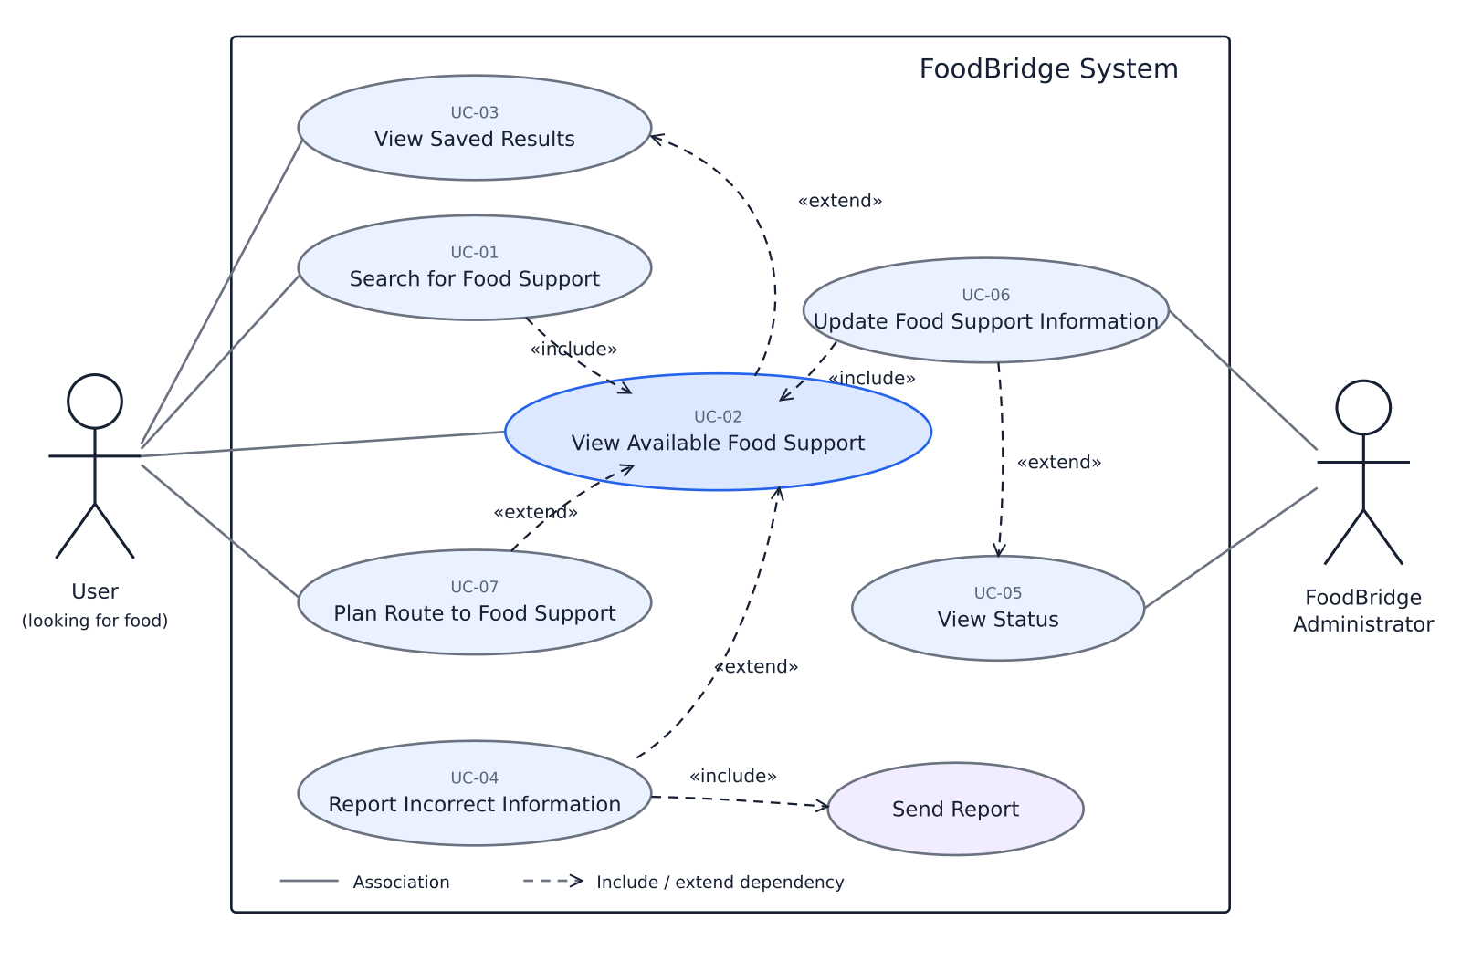Old Design
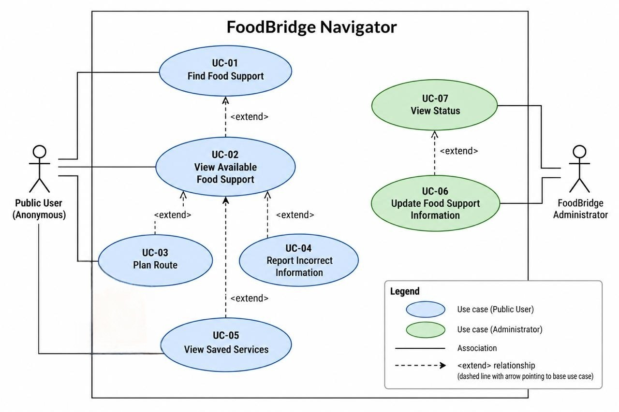
Data Dictionary:

Term | Brief description | Principal attributes and constraints | Relationships
User | Any person interacting with FoodBridge. | sessionId; role; accessibility preferences. Role is public user, organisation staff, or administrator. | A user performs zero or more interactions. An authenticated user is linked to one account.
Public user | A user accessing unrestricted functions without an account. | Temporary session identifier; no stored identity is required. | A public user creates 0..* searches and submits 0..* correction reports.
Account | A persistent identity used for restricted functions. | Unique accountId; name; unique email; credential hash or identity-provider ID; status; exactly one role. | An account represents one organisation staff member or administrator and creates 0..* audit entries.
Organisation | A legal or community entity that provides food support. | Unique organisationId; official name; address; latitude; longitude; approved phone; approved website; source; last verification time. | An organisation provides 1..* services, may have 0..* staff, and may appear in duplicate-review items.
Service | One form of food support offered by one organisation. | Unique support type; dietary options; receipt mode; eligibility; referral requirement; hours; accessibility; public state. | A service belongs to exactly 1 organisation and has 0..* availability observations, reports, and recommendations.
Support type | A controlled category of assistance. | Code and label, e.g. cooked meal, food ration, food voucher, or food pantry. | A service has one support type; a search criterion may select zero or one type.
Search | One submitted request to discover services. | Unique/temporary searchId; created time; origin; criteria. | A search has exactly 1 search origin, exactly 1 criteria record, and 0..* recommendations.
Device location | Coordinates supplied by the user’s device with user permission. | Latitude; longitude; permission state; accuracy if supplied. | May become a search origin. It is not retained after the search session ends.
Search criteria | Optional constraints applied to approved services. | Support type; dietary needs; receipt mode; maximum distance; mobility requirement; preferred Singapore date/time; referral preference. | Exactly one criteria record belongs to one search and filters many services.
Recommendation | One ranked service in one search result set. | Rank; match factors; explanation; straight-line/route distance; estimated duration if available. | A recommendation links exactly 1 search to exactly 1 service.
Route | A provider-calculated path from an origin to a service. | Travel mode; geometry; distance; estimated duration; provider; request time; state. | A route links exactly 1 origin-service pair.
Operating status | Whether the organisation/service is open at a specified time. | Open, closed, opens-at time, closes-at time; based on approved hours. | Applies to one service at a time. It is independent of availability status.
Availability observation | Time-limited evidence about whether support was available. | Unique observationId; one status; observed time; valid-until time; source; one confidence level. | Applies to exactly 1 service and comes from exactly 1 data source.
Availability status | Stored state of an observation. | Exactly one of AVAILABLE, LIMITED, UNAVAILABLE, UNKNOWN, EXPIRED. | Qualifies one observation. EXPIRED is shown publicly as Availability unknown.
Correction report | A public claim that one listed service fact is wrong or outdated. | Unique reportId; service ID; one category; description (1–1000 characters); optional evidence; submission time; state. | Concerns exactly 1 service and becomes exactly 1 moderation item.
Change request | One field edit proposed by FoodBridge Administrator. | Unique requestId; target ID; exactly one field; old value; proposed value; required note; submission time; state. | Concerns exactly 1 organisation or service and becomes exactly 1 moderation item.
Update | A correction report or change request. | Unique itemId; type; target; state; submission time; decision; optional decision reason. | Wraps exactly 1 report or change request. It receives at most 1 decision.
Last verification time | The most recent time a displayed fact was checked against an accepted source. | Singapore timestamp; verifying source or actor. | Qualifies organisation, service, contact, hours, and availability information.

- Ui mockup (include brief descriptions)
- 5 features

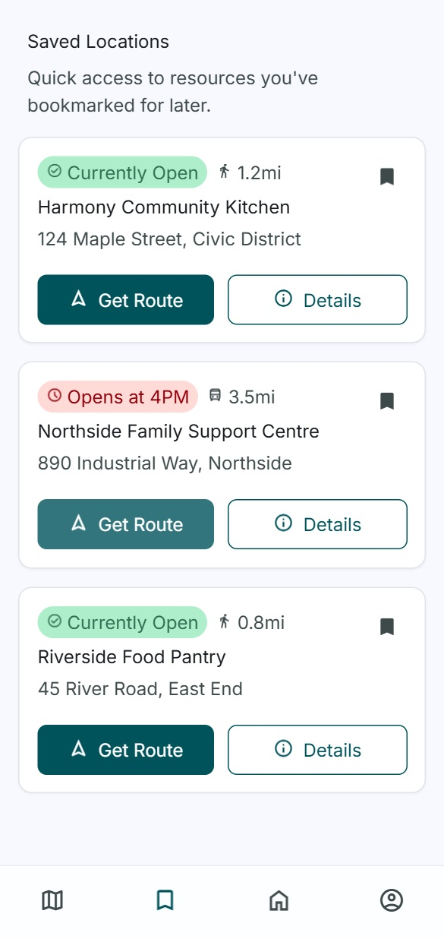
UI Mockup 1: Bookmarks page

UI Mockup 2: Map view page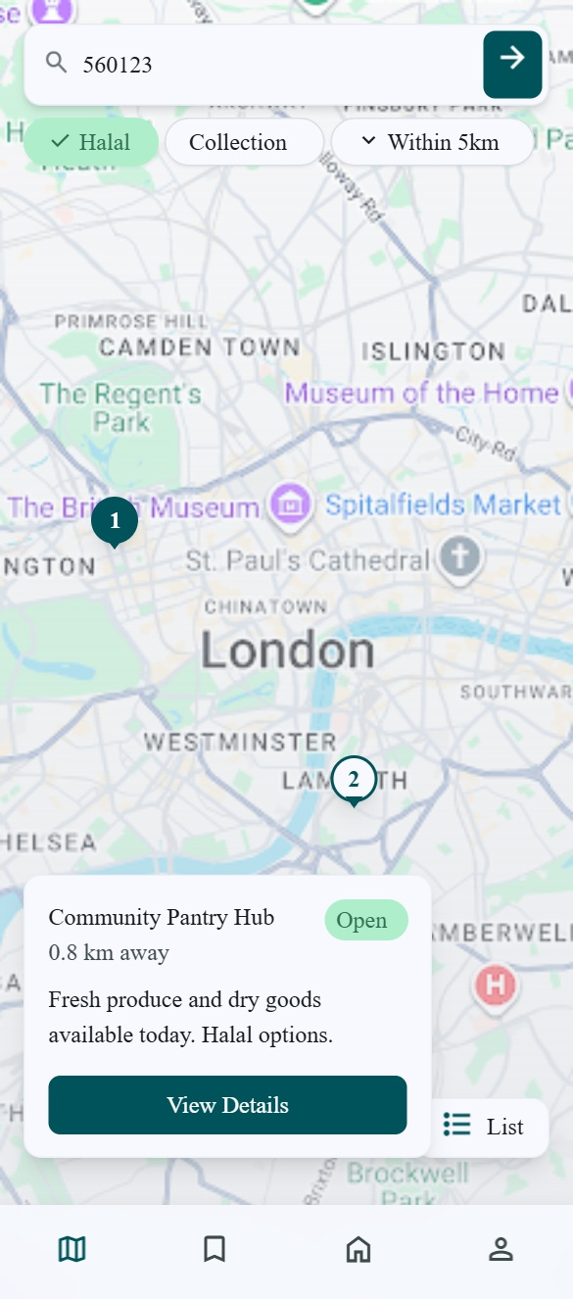
UI Mockup 3: Mock view food page
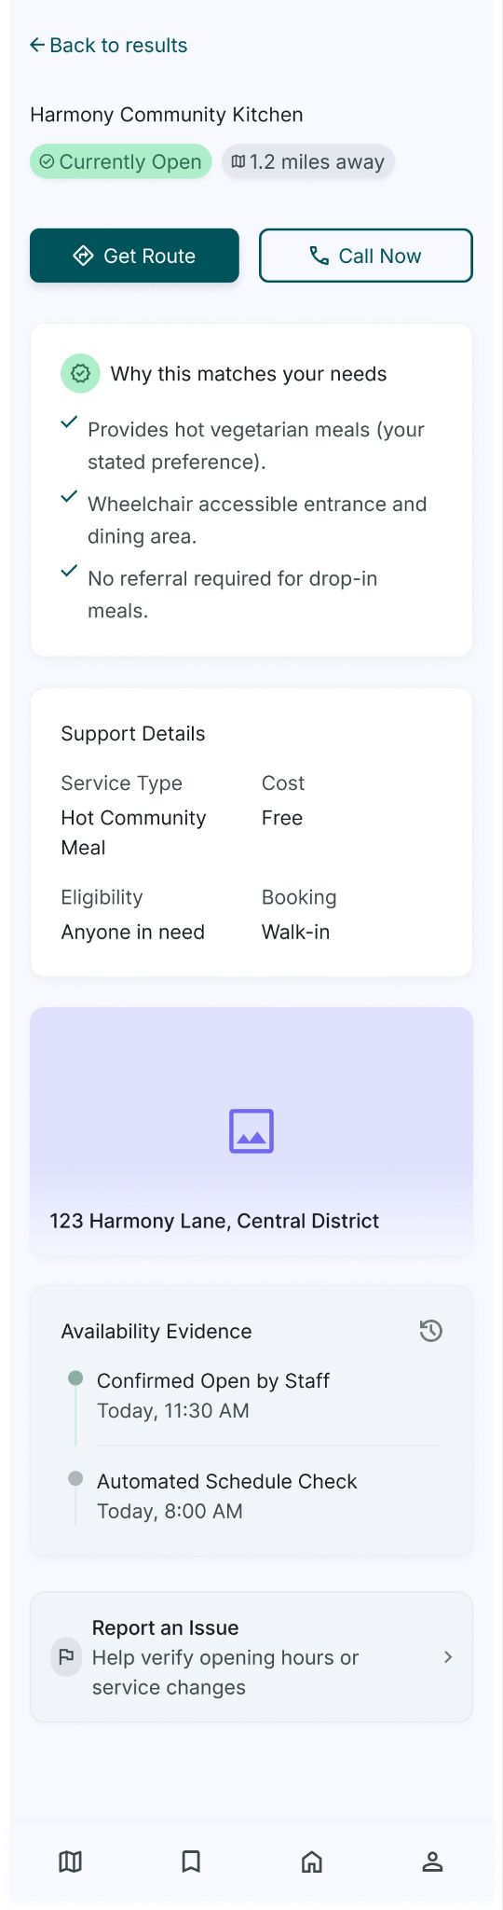

UI Mockup 4: Profile page
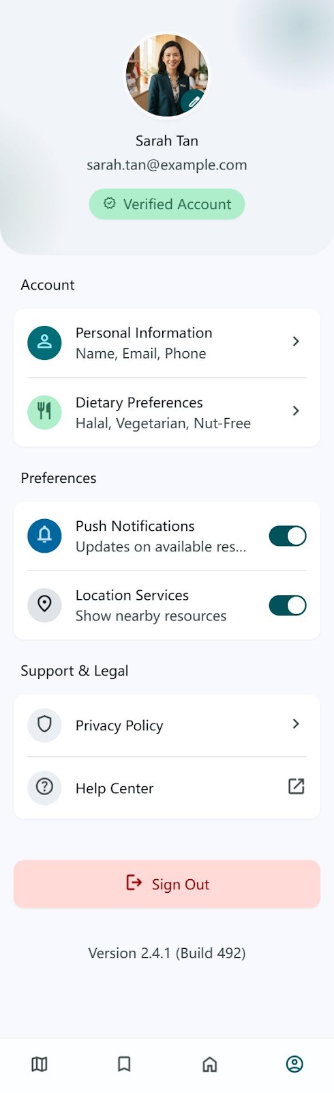
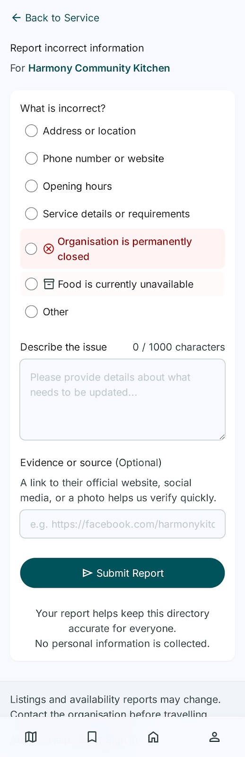
UI Mockup 5: Report issue page
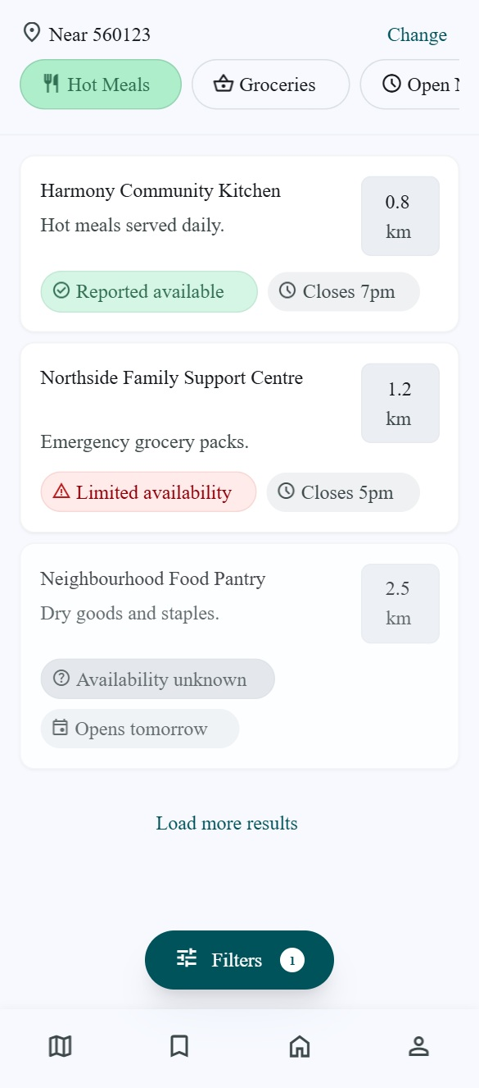
UI Mockup 6: Results page view
UI Mockup 7: Search page (with filtering)
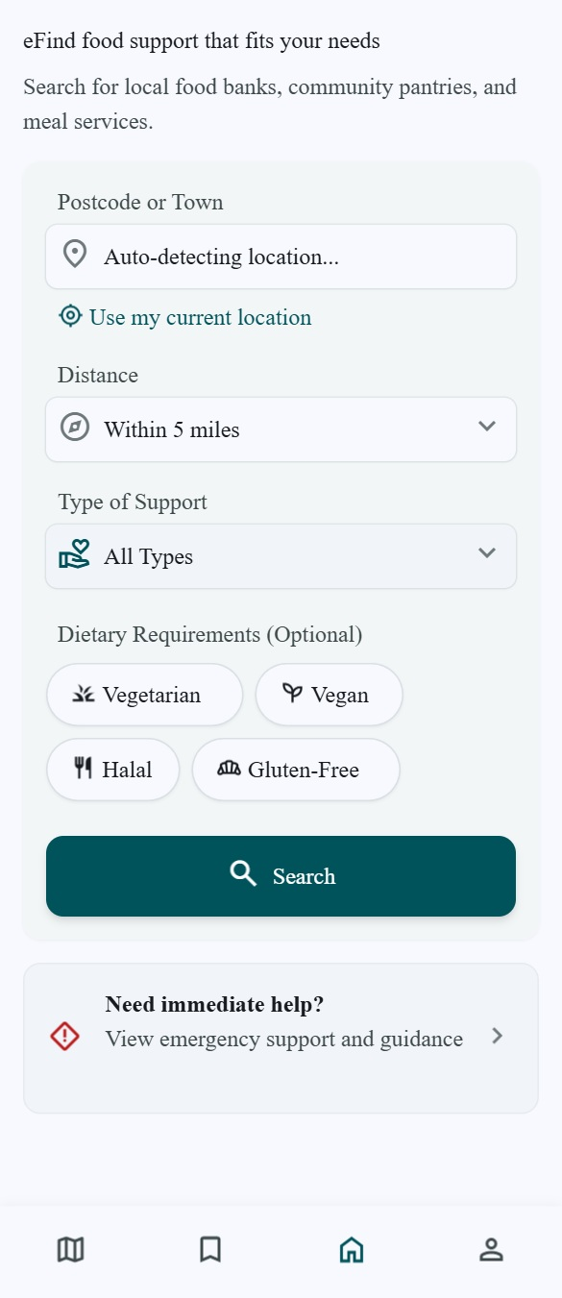

# FoodBridge Navigator — AI technology stack exercise

## Material supplied to the AI

The FoodBridge Navigator Lab 1 description and requirements (Singapore-only Android 12+ food-support search; approved service data; anonymous search, routing, reporting, bookmarks and local preferences; administrator moderation; authorised data imports) and the Lab 2 analysis class diagram, showing entity, boundary and control classes. The complete source documents are `lab 1.md` and `Lab2_Analysis.md`; the entity and boundary/control JPEG diagrams accompany this report.

## Exact prompt

> Based on the supplied FoodBridge Navigator system description and Lab 2 class diagrams, recommend a technology stack appropriate for an entry-level software engineering team. The first release targets Android 12+ in Singapore. It needs an Android UI, a small API for approved service search and moderation, local bookmarks/preferences, a persistent server-side data store, and OneMap integration. Keep the proposal small and explain the role of each technology. Treat the proposal as a discussion starting point.

## Original AI chat response

> I recommend a small Android client and one server application. Build the Android UI with Kotlin and Jetpack Compose. The client can keep bookmark IDs and optional preferences on the device, while obtaining current approved service details from the server; avoid storing the user's device location after the search session.
>
> Build a single Python FastAPI service for search, service details, public correction reports, administrator authentication and moderation. Keep matching, freshness labels, imports and approval decisions in this service so the same rules apply to every client. Use SQLite for a course prototype database containing approved organisations/services, availability observations, reports, change requests, decisions and import provenance. Use transactions for an approval and its audit record. If the team later needs deployment with more concurrent writers, reassess the database before production.
>
> Use OneMap through a small adapter for address lookup and routes, with a timeout and an explicit unavailable state. Import only authorised partner exports or a manually verified seed dataset. Keep the first version to one mobile app, one API service and one database. Test the main search, stale-data, report-validation and moderation paths before adding extra infrastructure.

This is the verbatim response generated for this exercise. Its product descriptions were checked against the official [Android Compose](https://developer.android.com/compose), [FastAPI](https://fastapi.tiangolo.com/), [SQLite](https://www.sqlite.org/about.html), and [OneMap](https://www.onemap.gov.sg/apidocs/) documentation on 19 September 2026. The suitability assessment is the AI's inference from the project needs, not a claim made by those documentation sites.

## Team opinion on Jetpack Compose

Jetpack Compose is a reasonable choice for the Android 12+ mockups because it supports native Kotlin UI and keeps screen state close to the dialog map. We would use it if the team is comfortable learning Kotlin; otherwise, the course project's schedule may favour whichever Android UI toolkit the team already knows. This opinion does not commit the team to a final stack.

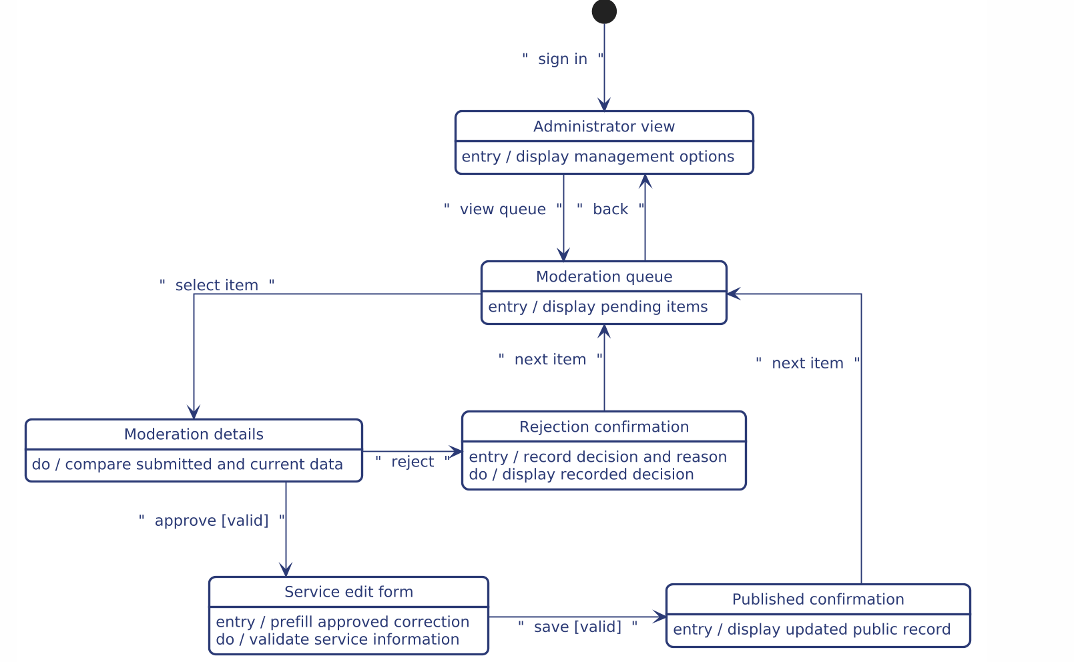

@startuml foodbridge-admin-dialog
skinparam backgroundColor white
skinparam shadowing false
skinparam defaultFontName "Segoe UI", Arial, sans-serif
skinparam defaultFontSize 12

' Force clean orthogonal routing with ample breathing room
skinparam linetype ortho
skinparam roundCorner 12
skinparam nodesep 70
skinparam ranksep 60
skinparam dpi 180

skinparam state {
BackgroundColor white
BorderColor #2b3a75
BorderThickness 1.8
FontColor #2b3a75
AttributeFontColor #2b3a75
ArrowColor #2b3a75
ArrowFontColor #2b3a75
StartColor #2b3a75
EndColor #2b3a75
}

left to right direction

state "Administrator view" as AdminView : entry / display management options
state "Moderation queue" as ModerationQueue : entry / display pending items
state "Moderation details" as ModerationDetails : do / compare submitted and current data
state "Rejection confirmation" as Rejected : entry / record decision and reason\ndo / display recorded decision
state "Service edit form" as ServiceEditForm : entry / prefill approved correction\ndo / validate service information
state "Published confirmation" as Published : entry / display updated public record

' Top-level sign in and queue access
[*] --> AdminView : sign in
AdminView --> ModerationQueue : view queue
ModerationQueue --> AdminView : back

' Inspection branch
ModerationQueue --> ModerationDetails : select item

' Reject branch (routes cleanly above)
ModerationDetails --> Rejected : reject
Rejected --> ModerationQueue : next item

' Approve & Publish branch (routes cleanly below)
ModerationDetails --> ServiceEditForm : approve [valid]
ServiceEditForm --> Published : save [valid]
Published --> ModerationQueue : next item

@enduml

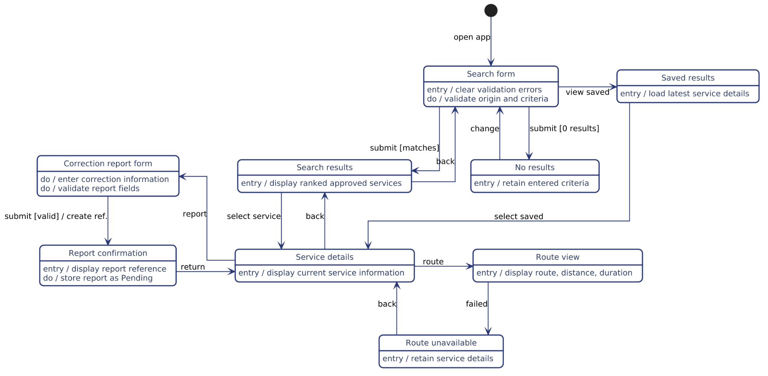
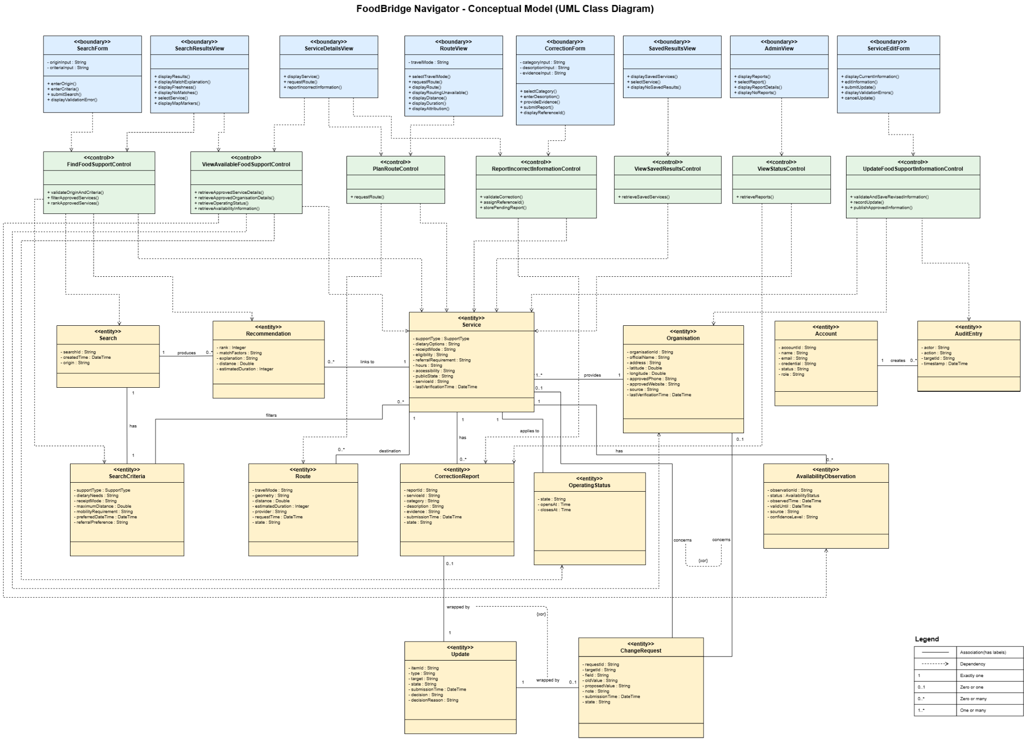

SC2006 Lab 2 Submission (SCSB K2)

Use Case Diagram

Use Case Descriptions

Use Case ID: | 01
Use Case Name: | Find Food Support
Created By: | Jamien | Last Updated By:
Date Created: | 7/9/2026 | Date Last Updated:

Actor: | Public User
Description: | Allows the Public User to find approved food support services that match the user’s location and needs
Preconditions: | The search form is available  - Approved food support service data is available and cached
Postconditions: | Matching Approved food services are displayed  - Results include match explanations, freshness information and map markers
Priority: | High
Frequency of Use: | On demand
Flow of Events: | The system displays the search form.  - The actor enters an origin and optional criteria.  - The actor submits the search.  - The system validates the origin and criteria.  - The system filters and ranks approved services.  - The system displays results, match explanations, freshness information, and map markers. (extends to Use Case - 02 (UC-02)
Alternative Flows: | Invalid origin: show an error and preserve input.  No matches: show recovery actions.  External failure: use cached data and show its update time.  Routing failure: show Travel time unavailable.  - The actor identifies incorrect service information and chooses to report it. (extends to Use Case - 04 (UC-04))
Exceptions: | Unexpected system failure: Display an error and allow the user to retry.
Includes: | -
Special Requirements: | Only approved services are displayed  - Results must include freshness information and match explanations  - User input must be preserved when validation fails
Assumptions: | The actor does not need to sign in  - The actor can provide an origin  - Current or cached approved service data is available
Notes and Issues: | -

Use Case ID: | 02
Use Case Name: | View Available Food Support
Created By: |  | Last Updated By:
Date Created: | 7/9/2026 | Date Last Updated:

Actor: | Public User
Description: | Decide whether a selected food support service may be suitable.
Preconditions: | - The selected service’s approved details, operating status, availability label, and supporting evidence are displayed.  - The actor can use any available approved contact action or request a route.
Postconditions: | - The selected service’s approved details, operating status, availability label, and supporting evidence are displayed.  - The actor can use any available approved contact action or request a route.
Priority: | High
Frequency of Use: | High
Flow of Events: | - The actor selects a service.  - The system retrieves its approved organisation and service details.  - The system displays the support type, eligibility, location, operating hours, and other approved details.  - The system displays operating status separately from food availability.  - The system presents approved telephone and website actions where available, plus a route action when directions can be requested.
Alternative Flows: | Unknown information is shown as Not confirmed.  If approved contact data is unavailable, no empty contact button is displayed.  Actor requests directions: UC-03 Plan Route begins.  Actor identifies incorrect information: UC-04 Report Incorrect Information begins.
Exceptions: | Unexpected system failure: display an error and allow the user to retry.
Includes/Extends: | -
Special Requirements: | -
Assumptions: | The selected service has approved information available or cached.
Notes and Issues: | -

Use Case ID: | 03
Use Case Name: | Plan Route
Created By: |  | Last Updated By:
Date Created: | 7/9/2026 | Date Last Updated:

Actor: | Public User
Description: | Allows a public user to request and view a route from a chosen origin to a selected food-support service
Preconditions: | 1. The actor has selected a food-support service.  2. The selected service has a valid destination location.  3. A valid starting location is available from the search origin, device location, or actor input.  4. The route action is available on the service-detail page.
Postconditions: | Success: A route map, route distance, and estimated duration are displayed.  Failure: The selected service’s details remain visible and a routing-unavailable message is displayed.  No service or user information is modified.
Priority: | High
Frequency of Use: | Often - Whenever the user needs the direction to a selected service.
Flow of Events: | - The actor requests a route and selects a travel mode.  - The system sends the origin and destination to OneMap.  - OneMap returns a route.  - The system displays the route, distance, duration, and attribution.
Alternative Flows: | A1 — Starting location is unavailable: The system asks the actor to enter an address or six-digit Singapore postal code.  A2 — Device-location permission is denied: The system allows the actor to manually enter an address or postal code.  A3 — OneMap cannot return a route: The system displays Route unavailable, keeps the service details visible, and allows the actor to retry or use an available contact action.
Exceptions: | E1 — OneMap is temporarily unavailable: The system displays a routing-unavailable message and allows the actor to retry later.  E2 — Network or unexpected system failure: The system displays an error message without removing the selected service’s details.  E3 — The destination location is invalid or missing: The system does not submit the route request and informs the actor that directions are currently unavailable.
Includes/Extends: | -
Special Requirements: | -
Assumptions: | 1. The actor has network access when requesting the route.  2. The actor entered a valid origin/ destination
Notes and Issues: | -

Use Case ID: | 04
Use Case Name: | Report incorrect Information
Created By: |  | Last Updated By:
Date Created: | 7/9/2026 | Date Last Updated:

Actor: | Public User
Description: | Allows a public user to submit a correction report when the user believes that information displayed for a food-support service is inaccurate, incomplete, or outdated.
Preconditions: | 1. The actor is viewing an approved food-support service.  2. The correction-reporting action is available.  3. The selected service has a valid identifier that can be associated with the report.
Postconditions: | Success: The correction report is stored with a Pending status and linked to the selected service. A unique reference identifier is displayed to the actor.  Failure: No report is stored, and the actor’s entered information is preserved where possible. Published service information is not changed by submitting a report.
Priority: | Medium
Frequency of Use: | Occasional — whenever a public user notices suspected incorrect, incomplete, or outdated service information.
Flow of Events: | 1. The actor selects the report-incorrect-information action for a service.  2. The system displays the correction form and identifies the selected service.  3. The actor selects one correction category.  4. The actor enters a description of the suspected error.  5. The actor optionally provides supporting evidence, if this feature is available.  6. The actor submits the correction report.  7. The system validates the selected category and description.  8. The system assigns a unique reference identifier to the report.  9. The system stores the report with a Pending status and links it to the selected service.  10. The system displays the reference identifier and informs the actor that the report is awaiting administrator review.
Alternative Flows: | A1 — No category is selected: The system displays an error beside the category control and in the validation summary. The actor’s other input is preserved.  A2 — Description is missing or invalid: The system explains that the description must contain between 1 and 1000 characters. The actor’s input is preserved for correction.
Exceptions:
Includes/Extends: | -
Special Requirements: | -
Assumptions: | 1. The actor has network access when requesting the route.  2. The actor entered a valid origin/ destination
Notes and Issues: | -

Use Case ID: | 05
Use Case Name: | View Saved Services
Created By: |  | Last Updated By:
Date Created: | 7/9/2026 | Date Last Updated:

Actor: | Public User
Description: | Allows the user to view food-support services saved during previous sessions.
Preconditions: | The user has previously saved at least one food-support service.
Postconditions: | The saved services are displayed. No saved information is changed.
Priority: | Medium
Frequency of Use: | Occasional
Flow of Events: | 1. The actor opens the saved-results tab.  2. The system retrieves the saved services.  3. The system displays the saved services.  4. The actor selects a service.  5. The system displays its details through UC-02.
Alternative Flows: | If no services have been saved, the system displays No saved results and provides an action to find food support.
Exceptions: | If the saved results cannot be loaded, the system displays an error and allows the actor to retry
Includes/Extends: | -
Special Requirements: | Saved services must use their latest approved information.
Assumptions: | Saved results are stored on the same device
Notes and Issues: | -

Use Case ID: | 06
Use Case Name: | Update Food Support Information
Created By: |  | Last Updated By:
Date Created: | 7/9/2026 | Date Last Updated:

Actor: | FoodBridge Administrator
Description: | Allows an administrator to update approved organisation and food-support service information
Preconditions: | The administrator is signed in and authorised. The organisation or service record exists.
Postconditions: | The approved information is updated and the change is recorded in the audit log.
Priority: | High
Frequency of Use: | Medium
Flow of Events: | 1. The system displays organisations and services available for update.  2. The administrator searches for and selects a record.  3. The system displays its current approved information, source, and last verification time.  4. The administrator selects Edit information.  5. The system displays an editable form containing the current values.  6. The administrator updates the required fields, such as support type, dietary options, operating hours, telephone number, location, service state, or delivery information.  7. The administrator submits the update.  8. The system validates and saves the revised information.  9. The system records the administrator, action, record identifier, and update time.  10. The system publishes the revised values as approved information.
Alternative Flows: | Invalid information: The system displays validation errors and preserves the administrator’s input.  Administrator cancels: The system discards the unsaved changes and returns to the current record.
Exceptions: | If a system or database failure prevents the update, the system displays an error, keeps the existing approved information unchanged, and allows the administrator to retry.
Includes/Extends: | UC-07 — View Status
Special Requirements: | Only authorised administrators may update information. Every update must record the administrator, action, target record, and timestamp.
Assumptions: | The administrator has permission to approve and publish changes. The updated information comes from a reliable source.
Notes and Issues: | -

Use Case ID: | 07
Use Case Name: | View Status
Created By: |  | Last Updated By:
Date Created: | 7/9/2026 | Date Last Updated:

Actor: | FoodBridge Administrator
Description: | Allows an administrator to view pending and previously assessed correction reports.
Preconditions: | The administrator is signed in and authorised to access the administrator view.
Postconditions: | The selected report details are displayed. No report information is changed.
Priority: | High
Frequency of Use: | Medium
Flow of Events: | 1. The actor opens the administrator view.  2. The system displays new and previously assessed reports.  3. For each report, the system displays its reference ID, category, description, submission time, and current status.  4. The actor selects a report.  5. The system displays the complete report details and related service information.
Alternative Flows: | No reports: The system displays No reports available.  Update information: The actor chooses to update the related service information, initiating UC-06.
Exceptions: | If reports cannot be retrieved, the system displays an error and allows the actor to retry.
Includes/Extends: | -
Special Requirements: | Only authorised administrators may view reports. Report statuses and details must reflect the latest stored information.
Assumptions: | Submitted reports have a unique reference ID, submission time, and current status.
Notes and Issues: | -

Conceptual Model (Class Diagram)

Dynamic Model (Dialog Map)

Technology Stack Discussion

- Material supplied to the AI

The FoodBridge Navigator Lab 1 description and requirements (Singapore-only Android 12+ food-support search; approved service data; anonymous search, routing, reporting, bookmarks and local preferences; administrator moderation; authorised data imports) and the Lab 2 analysis class diagram, showing entity, boundary and control classes. The complete source documents are `lab 1.md` and `Lab2_Analysis.md`; the entity and boundary/control JPEG diagrams accompany this report.

- Exact text prompt

> Based on the supplied FoodBridge Navigator system description and Lab 2 class diagrams, recommend a technology stack appropriate for an entry-level software engineering team. The first release targets Android 12+ in Singapore. It needs an Android UI, a small API for approved service search and moderation, local bookmarks/preferences, a persistent server-side data store, and OneMap integration. Keep the proposal small and explain the role of each technology. Treat the proposal as a discussion starting point.

- Original AI’s chat response

> I recommend a small Android client and one server application. Build the Android UI with Kotlin and Jetpack Compose. The client can keep bookmark IDs and optional preferences on the device, while obtaining current approved service details from the server; avoid storing the user's device location after the search session.
>
> Build a single Python FastAPI service for search, service details, public correction reports, administrator authentication and moderation. Keep matching, freshness labels, imports and approval decisions in this service so the same rules apply to every client. Use SQLite for a course prototype database containing approved organisations/services, availability observations, reports, change requests, decisions and import provenance. Use transactions for an approval and its audit record. If the team later needs deployment with more concurrent writers, reassess the database before production.
>
> Use OneMap through a small adapter for address lookup and routes, with a timeout and an explicit unavailable state. Import only authorised partner exports or a manually verified seed dataset. Keep the first version to one mobile app, one API service and one database. Test the main search, stale-data, report-validation and moderation paths before adding extra infrastructure.

- Team opinion on Jetpack Compose

Jetpack Compose is a reasonable choice for the Android 12+ mockups because it supports native Kotlin UI and keeps screen state close to the dialog map. We would use it if the team is comfortable learning Kotlin; otherwise, the course project's schedule may favour whichever Android UI toolkit the team already knows. This opinion does not commit the team to a final stack.

- Complete Use Case model (diagrams and descriptions)
- Design Model
  - Include encapsulation, loose coupling, high cohesion
- Class Diagram
- Dialog map
- System Architecture
- Application skeleton
- AI PDF report

